**Name : Hamad Nasir**

**Roll Number : 120312**

**Section : BSCS-6C**

**Lab 11**

# **Task 1:**

# **Source Code:**

**Class Truck:**

package truck;

/**

*

* @author Hamad nasir

*/

import java.awt.Color;

import java.awt.Graphics;

public class Truck

{

public static void main(String[] args)

{

DrawingPanel panel = new DrawingPanel(650, 650);

panel.setBackground(Color.WHITE);

Graphics g = panel.getGraphics();

DrawTruck(g,10,30,20);

DrawTruck(g,100,45,40);

DrawTruck(g,10,300,2);

DrawTruck(g,100,300,61);

DrawTruck(g,25,300,3);

DrawTruck(g,45,300,4);

DrawTruck(g,10,320,5);

}

static void DrawTruck(Graphics g,int x,int y,int size)

{

// draw the body

g.setColor(Color.BLACK);

g.fillRect(x, y, size*5, size/2*5); // x, y, width, ht

// draw the wheels

g.setColor(Color.RED);

g.fillOval(x+size*5/10, y+size*20/10, size, size);

g.fillOval(x+size*35/10, y+size*20/10, size, size);

// draw the window

g.setColor(Color.CYAN);

g.fillRect(x+size*35/10, y+size*5/10, size/2*3, size);

}

}

**Class DrawingPanel:**

package truck;

import java.awt.*;

import java.awt.event.*;

import java.awt.image.*;

import javax.imageio.*;

import javax.swing.*;

import javax.swing.event.*;

public class DrawingPanel implements ActionListener {

public static final int DELAY = 250; // delay between repaints in millis

private static final String DUMP_IMAGE_PROPERTY_NAME = "drawingpanel.save";

private static String TARGET_IMAGE_FILE_NAME = null;

private static final boolean PRETTY = true; // true to anti-alias

private static boolean DUMP_IMAGE = true; // true to write DrawingPanel to file

private int width, height; // dimensions of window frame

private JFrame frame; // overall window frame

private JPanel panel; // overall drawing surface

private BufferedImage image; // remembers drawing commands

private Graphics2D g2; // graphics context for painting

private JLabel statusBar; // status bar showing mouse position

private long createTime;

static {

TARGET_IMAGE_FILE_NAME = System.getProperty(DUMP_IMAGE_PROPERTY_NAME);

DUMP_IMAGE = (TARGET_IMAGE_FILE_NAME != null);

}

// construct a drawing panel of given width and height enclosed in a window

public DrawingPanel(int width, int height) {

this.width = width;

this.height = height;

this.image = new BufferedImage(width, height, BufferedImage.TYPE_INT_ARGB);

this.statusBar = new JLabel(" ");

this.statusBar.setBorder(BorderFactory.createLineBorder(Color.BLACK));

this.panel = new JPanel(new FlowLayout(FlowLayout.CENTER, 0, 0));

this.panel.setBackground(Color.WHITE);

this.panel.setPreferredSize(new Dimension(width, height));

this.panel.add(new JLabel(new ImageIcon(image)));

// listen to mouse movement

MouseInputAdapter listener = new MouseInputAdapter() {

public void mouseMoved(MouseEvent e) {

DrawingPanel.this.statusBar.setText("(" + e.getX() + ", " + e.getY() + ")");

}

public void mouseExited(MouseEvent e) {

DrawingPanel.this.statusBar.setText(" ");

}

};

this.panel.addMouseListener(listener);

this.panel.addMouseMotionListener(listener);

this.g2 = (Graphics2D)image.getGraphics();

this.g2.setColor(Color.BLACK);

if (PRETTY) {

this.g2.setRenderingHint(RenderingHints.KEY_ANTIALIASING, RenderingHints.VALUE_ANTIALIAS_ON);

this.g2.setStroke(new BasicStroke(1.1f));

}

this.frame = new JFrame("CS307 Drawing Panel");

this.frame.setResizable(false);

this.frame.addWindowListener(new WindowAdapter() {

public void windowClosing(WindowEvent e) {

if (DUMP_IMAGE) {

DrawingPanel.this.save(TARGET_IMAGE_FILE_NAME);

}

System.exit(0);

}

});

this.frame.getContentPane().add(panel);

this.frame.getContentPane().add(statusBar, "South");

this.frame.pack();

this.frame.setVisible(true);

if (DUMP_IMAGE) {

createTime = System.currentTimeMillis();

this.frame.toBack();

} else {

this.toFront();

}

// repaint timer so that the screen will update

new Timer(DELAY, this).start();

}

// used for an internal timer that keeps repainting

public void actionPerformed(ActionEvent e) {

this.panel.repaint();

if (DUMP_IMAGE && System.currentTimeMillis() > createTime + 4 * DELAY) {

this.frame.setVisible(false);

this.frame.dispose();

this.save(TARGET_IMAGE_FILE_NAME);

System.exit(0);

}

}

// obtain the Graphics object to draw on the panel

public Graphics2D getGraphics() {

return this.g2;

}

// set the background color of the drawing panel

public void setBackground(Color c) {

this.panel.setBackground(c);

}

// show or hide the drawing panel on the screen

public void setVisible(boolean visible) {

this.frame.setVisible(visible);

}

// makes the program pause for the given amount of time,

// allowing for animation

public void sleep(int millis) {

try {

Thread.sleep(millis);

} catch (InterruptedException e) {}

}

// take the current contents of the panel and write them to a file

public void save(String filename) {

String extension = filename.substring(filename.lastIndexOf(".") + 1);

// create second image so we get the background color

BufferedImage image2 = new BufferedImage(this.width, this.height, BufferedImage.TYPE_INT_RGB);

Graphics g = image2.getGraphics();

g.setColor(panel.getBackground());

g.fillRect(0, 0, this.width, this.height);

g.drawImage(this.image, 0, 0, panel);

// write file

try {

ImageIO.write(image2, extension, new java.io.File(filename));

} catch (java.io.IOException e) {

System.err.println("Unable to save image:\n" + e);

}

}

// makes drawing panel become the frontmost window on the screen

public void toFront() {

this.frame.toFront();

}

}

Output:

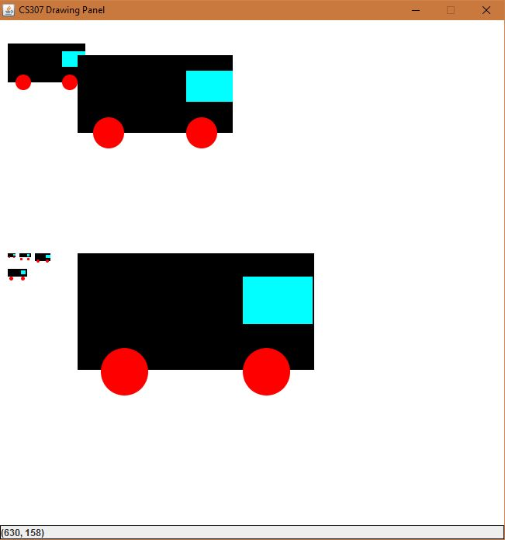

**Task 2:**

**Source Code:**

**Class Clock:**

package clock;

/**

*

* @author Hamad nasir

*/

import java.awt.BorderLayout;

import java.awt.Color;

import java.awt.Dimension;

import java.awt.Graphics;

import java.awt.Graphics2D;

import java.awt.Point;

import java.awt.RenderingHints;

import java.util.Calendar;

import javax.swing.JFrame;

import javax.swing.JPanel;

class Clock extends JFrame {

private static final long serialVersionUID = 1L;

private static final Color BACKGROUND_COLOR = new Color(132, 112, 255);

public Clock() {

ClockPanel container = new ClockPanel();

add(container, BorderLayout.CENTER);

setBackground(BACKGROUND_COLOR);

setDefaultCloseOperation(EXIT_ON_CLOSE);

setResizable(false);

pack();

setVisible(true);

}

public static void main(String[] args) {

new Clock();

}

}

class ClockPanel extends JPanel implements Runnable {

private static final long serialVersionUID = 1L;

Thread t = new Thread(this);

/** The coordinates used to paint the clock hands. */

int xHandSec, yHandSec, xHandMin, yHandMin, xHandHour, yHandHour;

/** The size of the clock. */

private final int HORIZONTAL_SIZE = 500;

private final int VERTICAL_SIZE = 500;

/** The length of the clock hands relative to the clock size. */

private final int secondHandLength = HORIZONTAL_SIZE / 2 - 50;

private final int minuteHandLength = HORIZONTAL_SIZE / 2 - 70;

private final int hourHandLength = HORIZONTAL_SIZE / 2 - 100;

/** The distance of the dots from the origin (center of the clock). */

private final int DISTANCE_DOT_FROM_ORIGIN = HORIZONTAL_SIZE / 2 - 40;

private final int DIAMETER_BIG_DOT = 8;

private final int DIAMETER_SMALL_DOT = 4;

private final static Color GREY_COLOR = new Color(160,160,160);

public ClockPanel() {

setMinimumSize(new Dimension(HORIZONTAL_SIZE, VERTICAL_SIZE));

setMaximumSize(new Dimension(HORIZONTAL_SIZE, VERTICAL_SIZE));

setPreferredSize(new Dimension(HORIZONTAL_SIZE, VERTICAL_SIZE));

setLayout(null);

t.start();

}

/**

* At each iteration we recalculate the coordinates of the clock hands,

* and repaint everything.

*/

public void run(){

while(true){

try{

//using an getInstance() method that returns the current time object

Calendar atpresent = Calendar.getInstance();

/* TODO: Get Seconds from the Calender Class; Replace zero with your code */

int presentSecond = atpresent.get(Calendar.SECOND);

/* TODO: Get Minutes from the Calender Class; Replace zero with your code */

int presentMinute = atpresent.get(Calendar.MINUTE);

/* TODO: Get Hours from the Calender Class; Replace zero with your code */

int presentHour = atpresent.get(Calendar.HOUR);

/*TODO: Calculate the X Coordinate of Seconds Handle using minToLocation method */

xHandSec = (int) minToLocation(presentSecond,secondHandLength).getX();

/*TODO: Calculate the Y Coordinate of Seconds Handle using minToLocation method */

yHandSec = (int) minToLocation(presentSecond,secondHandLength).getY();

/*TODO: Calculate the X Coordinate of Minutes Handle using minToLocation method */

xHandMin = (int) minToLocation(presentMinute,secondHandLength).getX();

/*TODO: Calculate the Y Coordinate of Minutes Handle using minToLocation method */

yHandMin = (int) minToLocation(presentMinute,secondHandLength).getY();

/*TODO: Calculate the X Coordinate of Hours Handle using minToLocation method */

xHandHour = (int)minToLocation(presentHour * 5 + getRelativeHour(presentMinute), hourHandLength).getX();

/*TODO: Calculate the Y Coordinate of Hours Handle using minToLocation method */

yHandHour = (int)minToLocation(presentHour * 5 + getRelativeHour(presentMinute), hourHandLength).getY();

repaint();

Thread.sleep(500);

} catch(InterruptedException ie){

ie.printStackTrace();

}

}

}

/**

* Returns how much the hour hand should be ahead

* according to the minutes value.

* 04:00, return 0.

* 04:12, return 1, so that we move the hour handle ahead of one dot.

* @param min The current minute.

* @return The relative offset to add to the hour hand.

*/

private int getRelativeHour(int min) {

return min / 12;

}

protected void paintComponent(Graphics g){

Graphics2D g2 = (Graphics2D)g;

g2.setRenderingHint(RenderingHints.KEY_ANTIALIASING,

RenderingHints.VALUE_ANTIALIAS_ON);

g2.clearRect(0, 0, getWidth(), getHeight());

// Draw the dots

g2.setColor(GREY_COLOR);

for (int i = 0; i < 60; i++) {

Point dotCoordinates = minToLocation(i, DISTANCE_DOT_FROM_ORIGIN);

g2.setColor((i <= Calendar.getInstance().get(Calendar.SECOND)) ? Color.white : GREY_COLOR);

if (i % 5 == 0) {

// big dot

/*TODO: Draw the big dots using the fillOval method */

//Using the x and y cordinates of the point

g2.fillOval(dotCoordinates.x , dotCoordinates.y , DIAMETER_BIG_DOT, DIAMETER_BIG_DOT);

} else {

// small dot

/*TODO: Draw the small dots using the fillOval method */

g2.fillOval(dotCoordinates.x , dotCoordinates.y , DIAMETER_SMALL_DOT, DIAMETER_SMALL_DOT);

}

}

//Changing the color of each Hand so that it is visible

// Draw the clock hands

g2.setColor(Color.ORANGE);

g2.drawLine(HORIZONTAL_SIZE / 2, VERTICAL_SIZE / 2, xHandSec, yHandSec);

/*TODO: Draw the minute hand here, just like the seconds hand */

g2.setColor(Color.BLUE);

g2.drawLine(HORIZONTAL_SIZE / 2, VERTICAL_SIZE / 2, xHandMin, yHandMin);

/*TODO: Draw the hour hand here, just like the seconds hand */

g2.setColor(Color.ORANGE);

g2.drawLine(HORIZONTAL_SIZE / 2, VERTICAL_SIZE / 2, xHandHour, yHandHour);

}

/**

* Converts current second/minute/hour to x and y coordinates.

* @param min The current minute

* @param radius The radius length

* @return the coordinates point

*/

private Point minToLocation(int timeStep, int radius) {

double t = 2 * Math.PI * (timeStep-15) / 60;

int x = (int)(HORIZONTAL_SIZE / 2 + radius * Math.cos(t));

int y = (int)(VERTICAL_SIZE / 2 + radius * Math.sin(t));

return new Point(x, y);

}

}

**Output:**

